**NEGOTIABLE INSTRUMENTS ACT (NI ACT) 1881**

**INTRODUCTION**

In India, the Negotiable Instruments Act was passed during 1881 which came into force from March 01, 1882. Originally, it had 137 Sections. Sections 138 to 142 were added in 1988, and Sections 143 to 147 were added during December 2002. At present it has 147 sections and 17 Chapters. It extends to the whole of India. According to Section 13 (a) of the Act, Negotiable Instruments means Promissory Note (PN), Bill of Exchange (BOE) and Cheque.

Features of Negotiable Instruments are as under:

* A negotiable instrument is one which is freely used by the parties in their business deal as a medium of payment.
* The word ‘negotiable’ means the transfer of ownership of the instrument from one person to another person for the purpose of consideration.
* Transferred Negotiable Instruments will further transfer without any restriction;
* Transferee taking the instrument for value and in good faith, gets better and absolute title despite any defect in the title of the transferor.
* The property in a negotiable instrument, i.e. the complete right of ownership, and not merely the possession passes, in the case of bearer instruments, by mere delivery, and in case of order instruments, by endorsement and delivery.
* The holder in due course is not, in any way, affected by the defect of the title of his transferor or of any prior party.
* The holder in due course can sue upon a negotiable instrument in his own name.
* The transferee of a negotiable instrument is known as ‘holder in due course.’ A bona fide transferee for value is not affected by any defect of title on the part of the transferor or of any of the previous holders of the instrument.
* The instrument may be defined as a written document which creates a right in favour of some person.
* Negotiable instrument means Promissory Note (PN), Bill of Exchange (BE), and Cheque payable to order or bearer.

**DIFFERENT TYPES OF NEGOTIABLE INSTRUMENTS**

**PROMISSORY NOTES**

Section 4 of the Act defines, “A promissory note is an instrument in writing (note being a bank-note or a currency note) containing an unconditional undertaking, signed by the maker, to pay a certain sum of money to or to the order of a certain person, or to the bearer of the instruments.” Example- If A writes “I promise to pay B or order Rs. 5000”.

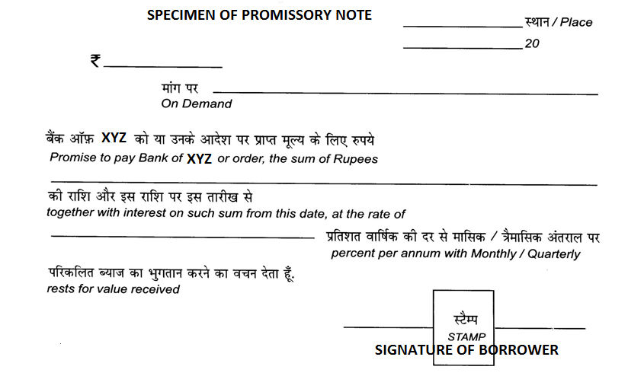

An instrument to be a promissory note must possess the following elements:

1. It must be in writing,
2. It must certainly be an express promise or clear understanding to pay a certain sum of money,
3. The promise should be to pay money and money only,
4. Promise to pay must be unconditional,
5. It should be signed by the maker,
6. The maker & payee must be certain.

**BILL OF EXCHANGE**

Section 5 of the Act defines, “A bill of exchange is an instrument in writing containing an unconditional order, signed by the maker, directing a certain person to pay a certain sum of money only to, or to the order of a certain person or to the bearer of the instrument”.

A bill of exchange, therefore, is a written acknowledgement of the debt, written by the creditor and accepted by the debtor. There are usually three parties to a bill of exchange drawer, acceptor or drawee and payee. Drawer himself may be the payee.

For example, Mr. Alpha directed to Mr. Gama for payment of Rs. 100,000 to Mr. Beta.

**SPECIMEN OF A DEMAND BILL**

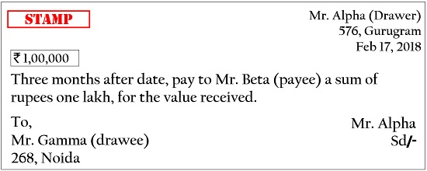

**Essential conditions of a bill of exchange**

(1) It must be in writing.

(2) It must be signed by the drawer.

(3) The drawer, drawee and payee must be certain.

(4) The sum payable must also be certain.

(5) It should be properly stamped.

(6) It must contain an express order to pay money and money alone.

**CHEQUES**

Section 6 of the Act defines “A cheque is a bill of exchange drawnon a specified banker, and not expressed to be payable otherwise than ondemand”.

A cheque is bill of exchange with two more qualifications, namely,

(i) it is always drawn on a specified banker, and

(ii) it is always payableon demand. Consequently, all cheque are bill of exchange, but all billsare not cheque.

A cheque must satisfy all the requirements of a bill ofexchange; that is, it must be signed by the drawer, and must contain an unconditional order on a specified banker to pay a certain sum of moneyto or to the order of a certain person or to the bearer of the cheque. It does not require acceptance.

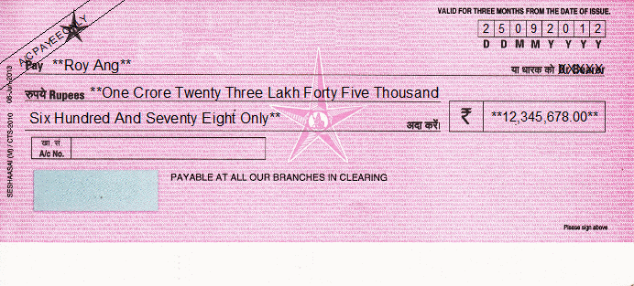

**OTHER NEGOTIABLE INSTRUMENTS**

The following are also considered as negotiable instruments:

* Demand Draft,
* Hundi,
* Traveller Cheque,
* Gift Cheque,
* Dividend Warrant,
* Interest Warrant,
* Bankers’ Cheque,
* Pay Order,
* Commercial Paper.

**NOT A NEGOTIABLE INSTRUMENTS**

The following are not Negotiable Instruments:

* Deposit Receipt,
* NSC,
* Postal Order,
* Share Certificate,
* Bill of Lading,
* Lorry Receipt,
* Airway Bill,
* Railway Receipt,
* Stock Invest,
* Dock Warrant

**PARTIES TO NEGOTIABLE INSTRUMENTS**

* **Drawer:** The maker of a bill of exchange is called the ‘drawer’.
* **Drawee:** The person directed to pay the money by the drawer is called the ‘drawee’.
* **Payee:** The person named in the instrument, to whom or to whose order the money is directed to be paid by the instrument is called the ‘payee’. He is the real beneficiary under the instrument.
* **Endorser:** When the holder transfers or endorses the instrument to anyone else, the holder becomes the ‘endorser’.
* **Endorsee:** The person to whom the bill is endorsed is called an ‘endorsee’.
* **Holder:** A person who is legally entitled to the possession of the negotiable instrument in his own name and to receive the amount thereof, is called a ‘holder’. He is either the original payee, or the endorsee. In case the bill is payable to the bearer, the person in possession of the negotiable instrument is called the ‘holder’.
* **Holder in Due Course:** defined in Section 9 pf the NI Act. Holder in due course is a person who became possessor of a NI for valuable consideration, in good faith, before becoming due, and without having any reason to believe that the person transferring the instrument was not entitled thereto.if before the amount mentioned in it became payable, and without having sufficient cause to believe that any defect existed in the title of the person from whom he derived his title.

**CLASSIFICATION OF BILLS**

Bills can be classified as:

(1) Inland and foreign bills. (Place wise)

(2) Time and demand bills. (Period wise)

(3) Trade and accommodation bills. (Nature wise)

**(1) Inland and Foreign Bills**

**Inland bill**

A bill is, named as an inland bill if drawn and made payable in India. A bill drawn or made in India & payable in or drawn upon any persons in India. The necessary requisite for inland bills are:

(a) It must be drawn in India on a person residing in India, whether payable in or outside India, or

(b) It must be drawn in India on a person residing outside India but payable in India.

**Foreign Bill**

A bill which is not an inland bill is a foreign bill. The following are the foreign bills:

1. A bill drawn outside India and made payable in India.

2. A bill drawn outside India on any person residing outside India.

3. A bill drawn in India on a person residing outside India and made payable outside India.

4. A bill drawn outside India on a person residing in India.

5. A bill drawn outside India and made payable outside India.

**(2) Time and Demand Bill**

**Time or Usance bills**

A bill payable after a fixed time is termed as a time bill. In other words, bill payable “after date” is a time or usance bill.

**Demand bill**

A bill payable at sight or on demand is termed as a demand bill.

**(3) Trade and Accommodation Bill**

**Trade bill**

A bill drawn and accepted for a genuine trade transaction is termed as a “trade bill”.

**Accommodation bill**

A bill drawn and accepted not for a genuine trade transaction but only to provide financial help to some party is termed as an “accommodation bill”.

**Example:** A, is in need of money for three months. He induces his friend B to accept a bill of exchange drawn on him for Rs. 1,000 for three months. The bill is drawn and accepted. The bill is an “accommodation bill”. A may get the bill discounted from his bankers immediately, paying a small sum as discount. Thus, he can use the funds for three months and then just before maturity he may remit the money to B, who will meet the bill on maturity. In the above example A is the “accommodated party” while B is the “accommodating party”.

**ACCEPTANCE OF BILL OF EXCHANGE**

The acceptance of a bill means signing by the drawer of a bill, on face with or without the words accepted and delivery thereof or giving notice of signing, to the holder of the bill. There are 2 types of acceptances i.e. general acceptance and qualified acceptance. In cases of several drawees not being partners, each of them can accept it for himself but not others without their authority (Sec 34).

**Dishonour of bill of exchange**

A bill of exchange is said to be dishonoured either by non-acceptance (when drawee defaults in acceptance) or by non-payment (when the acceptor/drawee makes default in payment). Similarly, where the drawee is incompetent to contract or acceptance is qualified, the bill is said to be dishonoured (Section 91 & 92).

**Presentation for acceptance**

As per Section 61, a usance bill payable after sight and bills payable on a fixed date (and not demand bills) require to be presented to drawee for acceptance to make him liable and also for calculation of due date.

**Negotiation**

when a promissory note, bill of exchange or cheque is transferred to any person so as to constitute that person the holder thereof, the instrument is said to be negotiated.

**Negotiation of a bearer instruments**

A bearer instrument is negotiated by mere delivery and no endorsement is required.

**Negotiation of an order instrument**

An order instrument can be negotiated by endorsement followed by delivery. It may be noted that legal heirs cannot complete the negotiation of a negotiable instrument with endorsement by the deceased merely by delivery.

**ENDORSEMENT**

Signing of an instrument on the back or on a slip of paper annexedthereto for the purpose of negotiation is called endorsement (Section 15). The person who transfersthe instrument is called endorser and the person to whom it is transferred is called endorsee. Various types of endorsements are as under:

1. **Blank Endorsement**

In a blank endorsement the endorser just signs his name without indicatingendorsee. It can be converted into full by writing name of a person above signatures. The effect of anendorsement in blank is that it makes an instrument drawn originally payable to order to bearer instrument for the purpose of negotiation which can be further negotiated by mere delivery**.**

1. **Endorsement in Full**

When, the endorser indicates the name of the endorsee it is called full endorsement.

1. **Sans Recourse Endorsement**

An endorsement in which endorser excludes his liability is termed 'sansrecourse' or ‘without recourse’ endorsement. In case of dishonour of instrument, the amount cannot be recovered from such endorser.

1. **Facultative**

An endorsement in which endorser waives the notice of dishonour is called Facultative endorsement But this is not applicable to other parties to the instrument**.**

1. **Restrictive endorsement**

An endorsement which restricts further right of negotiation is called as restrictive endorsement. For example if it is written in the endorsement as "Pay to Hari for my use" itis restrictive endorsement.

1. **Conditional Endorsement**

When along with endorsement, condition is imposed by endorser. For example, pay to C on completion of studies. Paying bank not to ensure compliance of condition. Condition binds endorser and endorsee only.

1. **Back-to-Back Endorsement**

An endorsement in which the endorser himself becomes endorsee iscalled as back to back endorsement and in such a case, the endorsee can recover the amount only from parties prior to his own endorsement.

1. **Negotiation Back**

When the drawer of a cheque himself becomes endorsee, it is called "Negotiation Back" and this cheque is treated as satisfied.

1. **Partial Endorsement**

The endorsement can be made only for full amount but in case part payment has been received and a note to that effect is made on the instrument, then the same can be endorsed for the balance amount**.**

1. **Forged Endorsement**

When endorsement is made by a person other than Holder by forging signatures of Holder Title does not pass to any person on the basis of such endorsement. A person getting instrument after such endorsement does not become holder.

1. **Regularity of endorsement**

Paying bank gets protection u/s 85(1) only when endorsement isregular (may not be genuine).

**PAYMENT IN DUE COURSE**

As per Section 10 of N.I**.** Act. ‘payment in due course means payment according to the apparent tenor of the instrument in good faith and without negligence to any person in possession thereof under circumstances which do not afford a reasonable ground for believing that he is not entitled to receive payment of the amount therein mentioned’.

Section 85 of NI Act conditions to be satisfied for being a paymentin due course.

* Payment is in accordance with the apparent tenor of the instrument ,
* Payment must be in good faith and without negligence,
* Payment must be made to the person in possession of the instrument,
* The banker should not have any reasons to "disbelieve" the integrity/honesty of the possessor, i.e. no reasons to think that he is not entitled to receive the payment.
* Payment must be made in money only.

**INCHOATE INSTRUMENTS**

As per section 20 of the NI Act, an instrument on which date, payee or amount is not mentioned is called as inchoate or incomplete instrument. Incomplete cheque can be completed by the Holder and the completion so made will not be treated as material alteration.

An instrument without signatures is not treated as an instrument at all.

**AMBIGUOUS INSTRUMENTS**

Where the instrument is drawn in such a manner that it can be construed both as PN or BE.

In the following cases, the instrument is taken as ambiguous:

(a) Where drawer and drawee are the same person.

(b) Where drawee is a fictitious person. E.g. Lord Krishna etc.

(c) Where drawee is a person incapable of entering into a contract.

**SOME IMPORTANT SECTIONS OF NEGOTIABLE INSTRUMENTS ACT:**

**01** Indian Paper Currency Act 1871 not to be affected by the provisions of this Act.

**04** Promissory note defined

**05** Bill of exchange defined

**06** Cheque defined (also include electronic cheque and truncated cheque)

**07** Drawer, drawee in case of need, acceptor, acceptor for honour, payee defined

**08** Holder defined

**09** Holder in due course defined

**10** Payment in due course: Paying banker's protection if payment is made in due course

**11** Inland instruments defined — drawn and made payable in India

**12** Foreign instruments defined.

**13** Negotiable instruments defined indirectly

**14** Negotiation defined.

**15** Endorsement and endorser defined

**16** Endorsement in blank and in full and endorsee defined.

**17** Ambiguous instruments

**18** Difference in amount in words and figures. Amount in words to be paid

**20** Inchoate stamped instruments - Holder has implied authority to complete the instrument..

**22** 3 days of grace are allowed on a usance Bill of Exchange/Promissory note.

**25** When a BOE/PN matures on a holiday — due date on the next preceding working day.

**26** A minor can draw, endorse and deliver and negotiate a negotiable instrument so as to bind all parties except himself.

**31** Banker's obligation to pay cheque & compensate drawer for wrongful dishonour.

**65** Presentment for acceptance to be made during the usual business hours.

**80.** If no interest rate mentioned in the Promissory Note interest @ 18% p.a. is to be paid.

**85-1** Paying banker protected by payment in due course of an order cheque which is properly endorsed by the payee or his agent.

**85-2** Protection to paying banker in case of a bearer cheque.

**85-A** Protection to paying banker in case of Bank drafts.

**87** Material alteration renders NI renders void,

**89** Protection to paying banker for materially altered instrument.

**99** Noting — must for foreign instruments

**100** Protest — must for foreign instruments

**105-107** Reasonable time — for presentment, dishonour and transmission of notice

**123** General crossing

**124** Special crossing

**125** Who can crass - holder, banker

**126-127** Payment of cheque crossed generally or specially

**128** Payment in due course of crossed cheques

**129** Paying banker liable to the true owner for loss when payment not made in due course.

**130 'Not** Negotiable' crossing — transferee does not get better title than that of transferor.

**131** Protection to collecting bank for crossed cheques subject to compliance of conditions

**131-A** Protection to collecting bank for crossed bank drafts.

**138** Drawer's liability for cheque returned unpaid for insufficient funds

**139** Unless proved otherwis9, it will be presumed that the cheque has been issued for the discharge of a debt/liability.

**140** The drawer cannot plead that he did not expect the cheque to be dishonoured.

**141** Offences by companies

**147** Offences to be compoundable